**Name: _________________________________________________ 614 Chapter 7 REVIEW**

NEATLY – SHOW ALL WORK! Be careful with your signs as well as the mode of calculator. Exact values are to be in radical form.

1. Use your calculator to find the indicated value.

a.) cot 232° = ____________________ b.) csc(–140°) = _______________

c.) sec(3.9)= ___________________ d.) = _________________ degrees



e.) = _________________radians f.) = _________________degrees



1. Determine the reference angle for each of the given angles.

a.) –321° b.) 1250° c.)



1. Convert to either degrees or radians.

a.) 4 = __________________° b.) –230° = ________________radians

c._ 3.2π = _________________° d.) 112°22’ = _________________ radians

1. A sector of a circle has an arc length of 410 cm and area of 315 cm2. Find the radius of the circle and the measure of the central angle. You may express your solution in either radians or degrees.
2. If a terminal ray of an angle passes through (–2, –8), find the .



1. Express each of the following in terms of its reference angle.

a.) cos 722°

b.) cot (–217°)

c.) 

1. Find each of the following. Exact values are required for a) and b).

a.)  (radians) b.) (radians)



c.)  (degrees) d.)  (degrees)

1. If , find the values of the other five trigonometric functions. Include a sketch as part of your solution.
2. List three angles in radian measure with .
3. Short answer.

a.) The number of radians in two revolutions is __________________________.

b.) The range of the sine function is ______________________________.

c.)  and in quadrant ________________________.

d.) In order to define inverse trigonometric functions, the domains of the trigonometric functions must be restricted because the trigonometric functions are not _________________________________________________.

e.) Given the equation  radians.

f.) The value of sin (–240°), in simplest radical form, is __________________________.

1. The graph shown below is *y* = csc *x*. Clearly explain why the graph has asymptotes. Use your knowledge of the unit circle to help with your explanation.

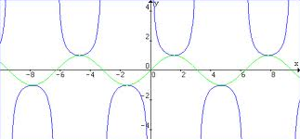

1. In 1954, Godzilla was scaled to be able to peer over the largest buildings in Tokyo. Godzilla has an apparent size of 0.002 radians from a pedestrian located 78,740 feet (approx. 15 miles) away from Tokyo. How tall was the tallest building in Tokyo in 1954?
2. Given , find the exact value(s), in radians, of .



1. Find the exact value(s) of .



1. Find the exact value(s) of .



1. Find the exact value(s) of .



1. Use the unit circle.

a.) If cos *x* = 0.27, determine cos (–*x*).

b.) If sin *x* = –0.57, determine sin (–*x*).

1. Identify each graph by its equation.

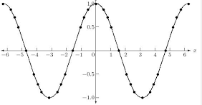

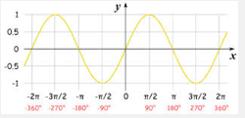

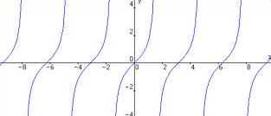

1. Fill in each blank with >, < or =.

a.) sin 70° _____ sin 65° b.) cos 70° _______ cos 65°

b.) sin 313° ______ sin 314° d.) 

e.)  e.) 