Math 604 – BC Calculus Chapter 3 Review
- If , then when , (1998 #6)

a) b) c) d) e)

- Let and be differentiable functions with the following properties:
(i) for all
(ii)

If and , then (1998 #8)

a) b) c) d) 0 e) 1

- What is the instantaneous rate of change at of the function given by (1998 #10)
a) b) c) d) 2 e) 6

- The is (1988 #29)
a) b) c) d) 3cot(3x) e) nonexistent

- A particle moves along the x-axis so that its position at time is given by . For what value of is the velocity of the particle zero?
(1998 #14)
a) 1 b) 2 c) 3 d) 4 e) 5

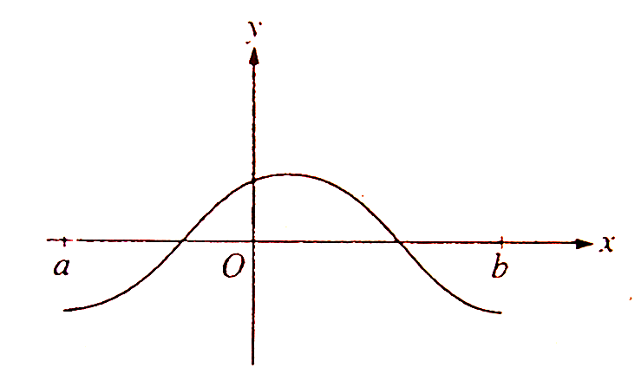

- The graph of is shown in the figure above. Which of the following could be the graph of the derivative of ? (1998 #23)

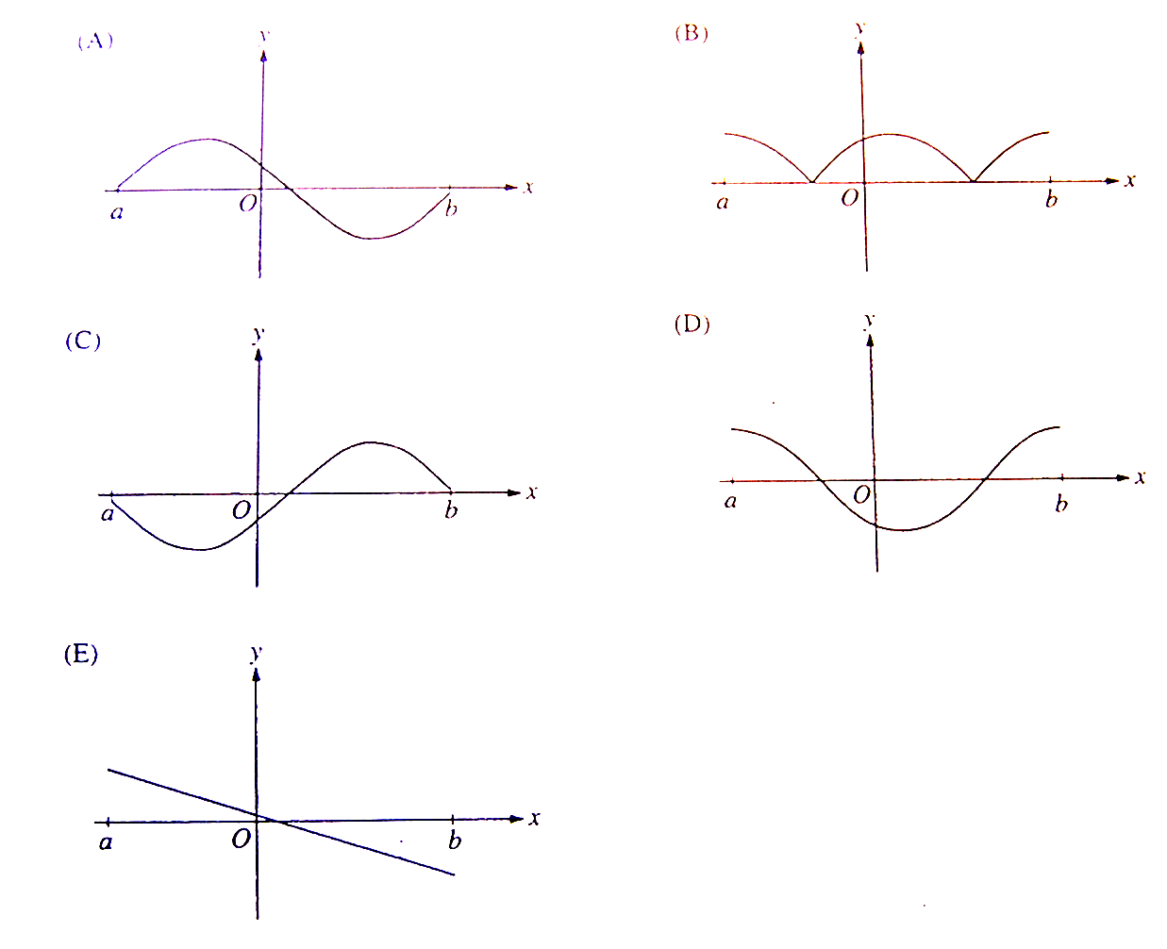

- If the function Princeton Review P.319 #42
is continuous and differentiable then ? (show work)

a) 0 b) 1 c) -14 d) -24 e) 26

- If , then (1998 #83)
a) b) c) d) 0 e) nonexistent

- If , then (1997 #2)

a) b) c) d) e)

- An equation of the line tangent to the graph of at is
(1997 #10)
a) b) c) d)
e)

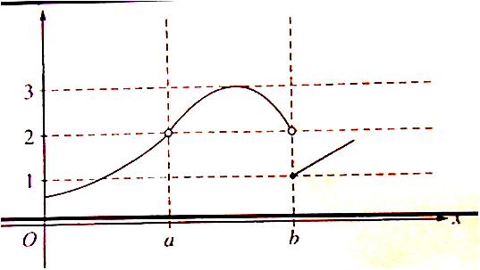

- The graph of the function is shown in the figure above. Which of the following statements about is true? (1997 #15)

a) b) c) d)

e) does not exist.

- If , what is the value of at the point (4,3) ? (1997 #17)

a) b) c) d) e)

- If , then (1993 #8)

a) b) c) d) e)

- If , then (1993 #31)

a) b) c) d) e)

- If is a differentiable function, then is given by which of the following?
(1993 #37)
a. I only b) II only c) I and II only d) I and III only e) I, II, and III

- If the second derivative of is given by , which of the following could be ? (1993 #38)
a) b) c) d)
e)

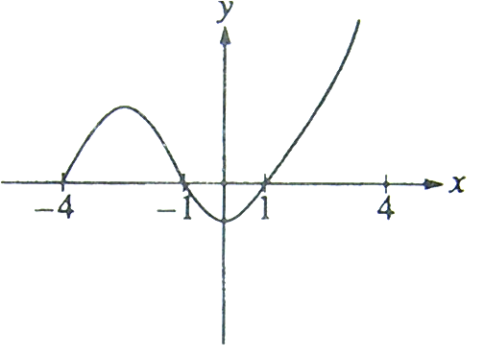

- The graph of is shown in the figure above. Which of the following could be the graph of ? (1993 #40)

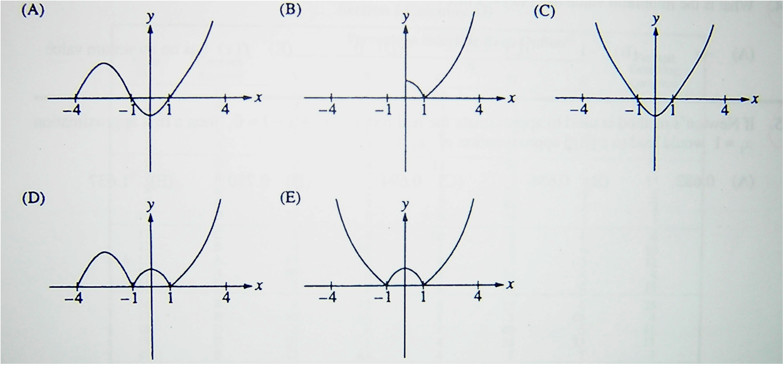

- At , the function given by is (1988 #27)

      - undefined
      - continuous but not differentiable
      - differentiable but not continuous
      - neither continuous nor differentiable
      - both continuous and differentiable

- Let . Show that using the limit definition of the derivative:

- The fundamental frequency of a wire is given as where: r: radius of wire, : length of the wire, d: density of the wire and T: the tension force holding the wire taught. Find an expression for :

a)

b)

