Example 1 For the following function identify the intervals where the function is increasing and decreasing and the intervals where the function is concave up and concave down. Use this information to sketch the graph.

Solution

Okay, we are going to need the first two derivatives so let’s get those first.
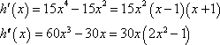

Let’s start with the increasing/decreasing information since we should be fairly comfortable with that after the last section.

There are three critical points for this function : , , and . Below is the number line for the increasing/decreasing information.
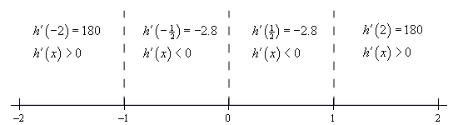

So, it looks like we’ve got the following intervals of increasing and decreasing.

Note that from the first derivative test we can also say that is a relative maximum and that is a relative minimum. Also is neither a relative minimum or maximum.

Now let’s get the intervals where the function is concave up and concave down. If you think about it this process is almost identical to the process we use to identify the intervals of increasing and decreasing. This only difference is that we will be using the second derivative instead of the first derivative.

The first thing that we need to do is identify the possible inflection points. These will be where the second derivative is zero or doesn’t exist. The second derivative in this case is a polynomial and so will exist everywhere. It will be zero at the following points.
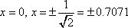

As with the increasing and decreasing part we can draw a number line up and use these points to divide the number line into regions. In these regions we know that the second derivative will always have the same sign since these three points are the only places where the function may change sign. Therefore, all that we need to do is pick a point from each region and plug it into the second derivative. The second derivative will then have that sign in the whole region from which the point came.

Here is the number line for this second derivative.
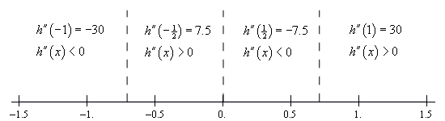

So, it looks like we’ve got the following intervals of concavity.
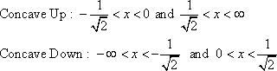

This also means that
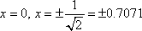
are all inflection points.

All this information can be a little overwhelming when going to sketch the graph. The first thing that we should do is get some starting points. The critical points and inflection points are good starting points. So, first graph these points. Now, start to the left and start graphing the increasing/decreasing information as we did in the previous section when all we had was the increasing/decreasing information. As we graph this we will make sure that the concavity information matches up with what we’re graphing.

Using all this information to sketch the graph gives the following graph.

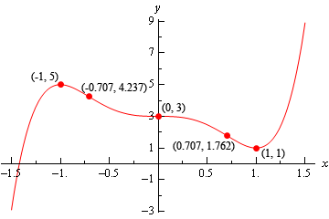

Example 2 Use the second derivative test to classify the critical points of the function,

Solution

Note that all we’re doing here is verifying the results from the first example. The second derivative is,

The three critical points ( , , and ) of this function are all critical points where the first derivative is zero so we know that we at least have a chance that the Second Derivative Test will work. The value of the second derivative for each of these are,

The second derivative at is negative so by the Second Derivative Test this critical point this is a relative maximum as we saw in the first example. The second derivative at is positive and so we have a relative minimum here by the Second Derivative Test as we also saw in the first example.

In the case of the second derivative is zero and so we can’t use the Second Derivative Test to classify this critical point. Note however, that we do know from the First Derivative Test we used in the first example that in this case the critical point is not a relative extrema.

Example 3 For the following function find the inflection points and use the second derivative test, if possible, to classify the critical points. Also, determine the intervals of increase/decrease and the intervals of concave up/concave down and sketch the graph of the function.

Solution

We’ll need the first and second derivatives to get us started.
The critical points are,
Notice as well that we won’t be able to use the second derivative test on to classify this critical point since the derivative doesn’t exist at this point. To classify this we’ll need the increasing/decreasing information that we’ll get to sketch the graph.

We can however, use the Second Derivative Test to classify the other critical point so let’s do that before we proceed with the sketching work. Here is the value of the second derivative at .

So, according to the second derivative test is a relative maximum.

Now let’s proceed with the work to get the sketch of the graph and notice that once we have the increasing/decreasing information we’ll be able to classify .

Here is the number line for the first derivative.
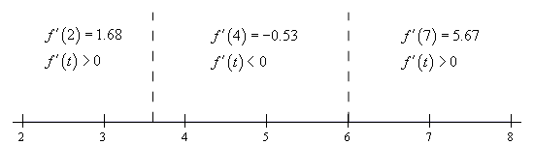

So, according to the first derivative test we can verify that is in fact a relative maximum. We can also see that is a relative minimum.

Be careful not to assume that a critical point that can’t be used in the second derivative test won’t be a relative extrema. We’ve clearly seen now both with this example and in the discussion after we have the test that just because we can’t use the Second Derivative Test or the Test doesn’t tell us anything about a critical point doesn’t mean that the critical point will not be a relative extrema. This is a common mistake that many students make so be careful when using the Second Derivative Test.

Okay, let’s finish the problem out. We will need the list of possible inflection points. These are,
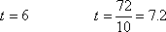
Here is the number line for the second derivative. Note that we will need this to see if the two points above are in fact inflection points.
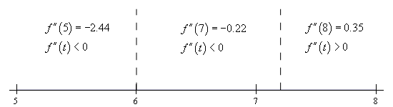

So, the concavity only changes at and so this is the only inflection point for this function.

Here is the sketch of the graph.
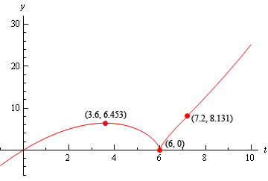

The change of concavity at is hard to see, but it is there it’s just a very subtle change in concavity.

