Problem Determine all the numbers c which satisfy the conclusions of the Mean Value Theorem for the following function.

Solution There isn’t really a whole lot to this problem other than to notice that since is a polynomial it is both continuous and differentiable (i.e., the derivative exists) on the interval given.
First let’s find the derivative.
Now, to find the numbers that satisfy the conclusions of the Mean Value Theorem all we need to do is plug this into the formula given by the Mean Value Theorem.
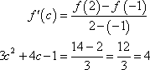
Now, this is just a quadratic equation,
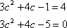
Using the quadratic formula on this we get,
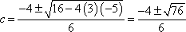
So, solving gives two values of c.
Notice that only one of these is actually in the interval given in the problem. That means that we will exclude the second one (since it isn’t in the interval). The number that we’re after in this problem is,
Be careful to not assume that only one of the numbers will work. It is possible for both of them to work.

