Problem
Determine the absolute extrema for the following function and interval.

Solution
Again, as with all the other examples we’ve done, this function is continuous on the given interval and so we know that this can be done.
First we’ll need the derivative and make sure you can do the simplification that we did here to make the work for finding the critical points easier.
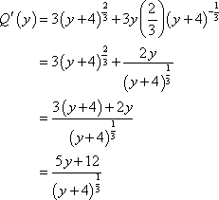
So, it looks like we’ve got two critical points.
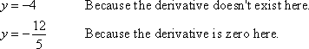
Both of these are in the interval so let’s evaluate the function at these points and the end points of the interval.
The function has an absolute maximum of zero at and the function will have an absolute minimum of -15 at . So, if we had ignored or forgotten about the critical point where the derivative doesn’t exist ( ) we would not have gotten the correct answer.

